Steps on downloading unity and creating a file:

1. Download unity (<https://store.unity.com/download?ref=personal>)
2. Accept the terms of service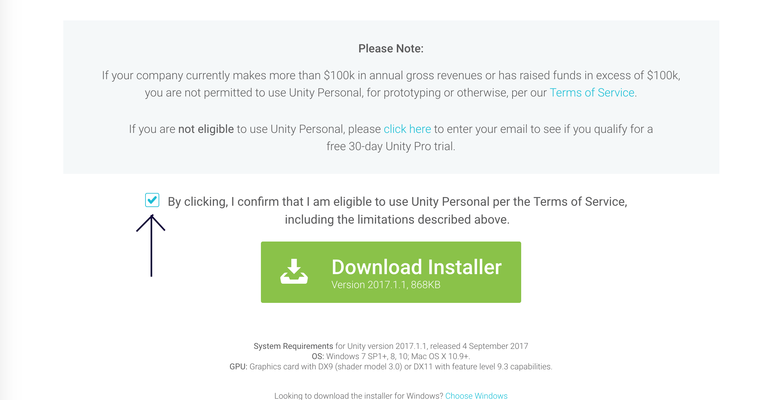
3. When downloading, choose to support most of the platforms (iOS, Android, WebGL, etc.)
4. Open it when downloading is finished
5. (optional) create a unity account and login
6. Open a new project 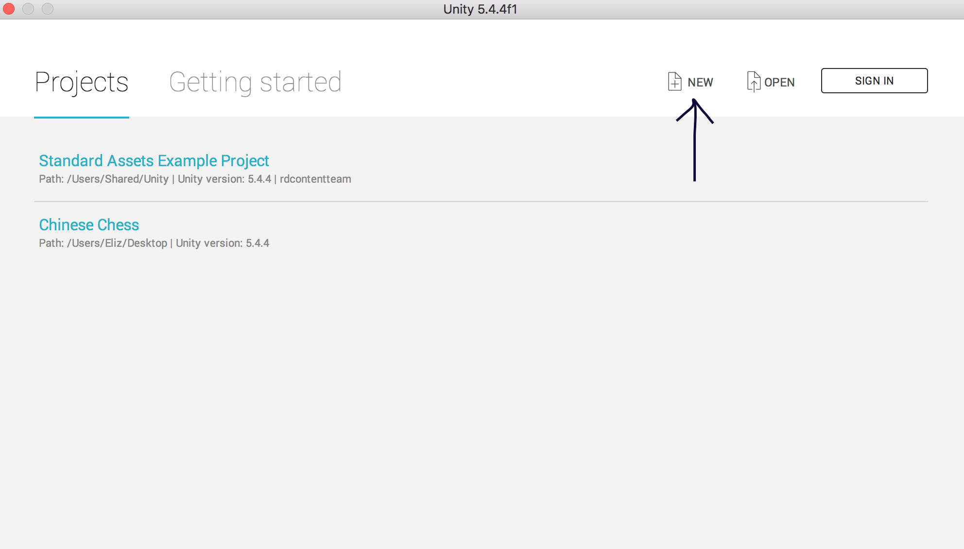
7. Rename your project and check 3D 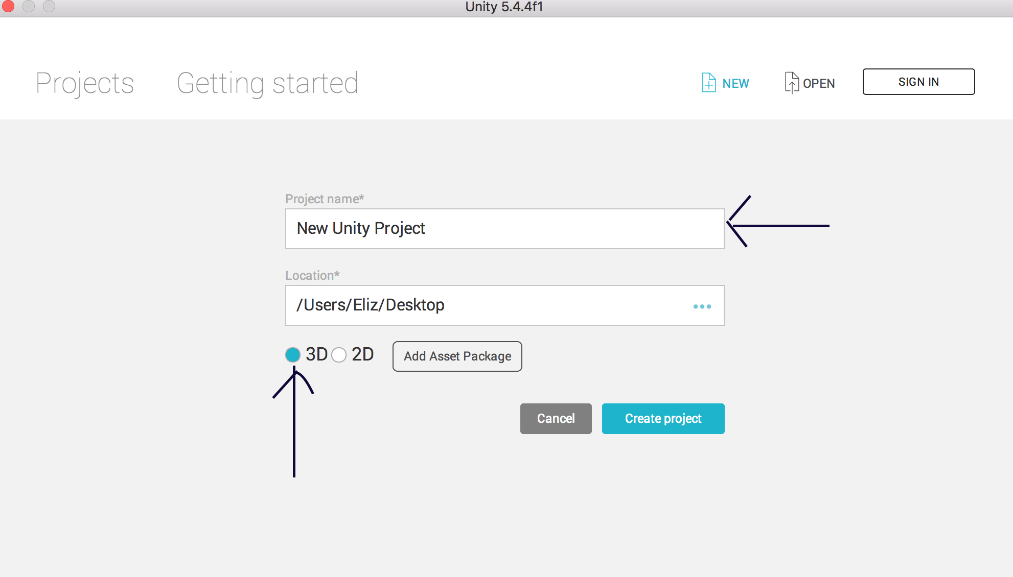
8. Click on create project
9. Your view now should be